  - Safety committee university
Provides that the employer has certified that

Student Name
Has completed all five modules of the online Safety Committee University, and is awarded this

Certificate of completion
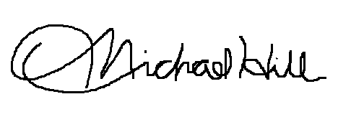
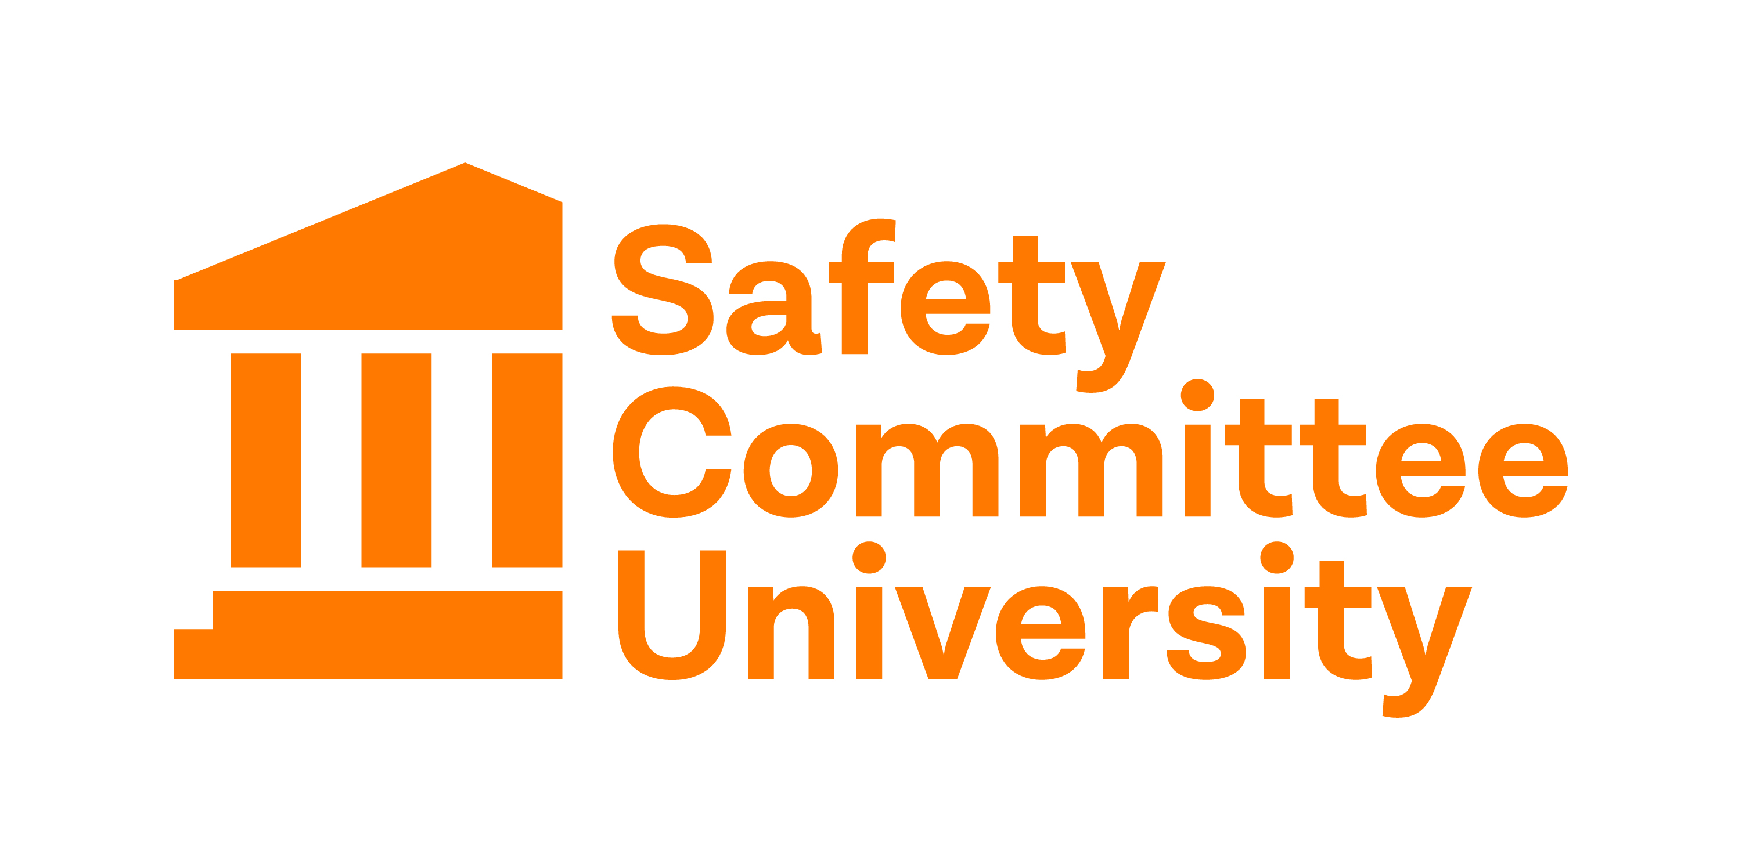
Dated: Click or tap to enter a date.
Employer Signature |  | Conference Chair

